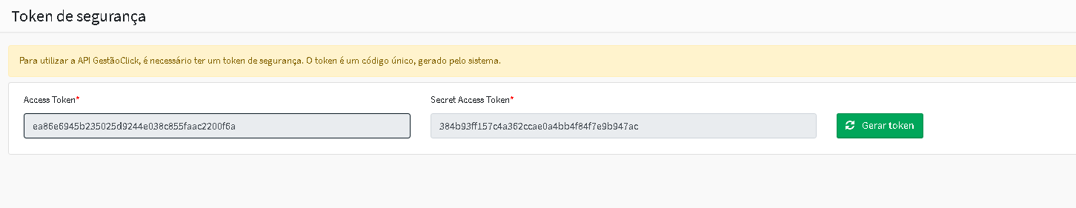
Access Token: ea86e6945b235025d9244e038c855faac2200f6a
Secret Access Token: 384b93ff157c4a362ccae0a4bb4f84f7e9b947ac
NOVAS API GERAS A PARTIR DE 01/05/2026
Access Token: 90d6f6f6a741248a6d7cef52015e0fcada662f73
Secret Access Token: 06b1c43ca9339432e74a23e7cecf6ead69f78cef

